Git Practical Documentation
Created the folder and and added the html file to the folder using visual studio code.
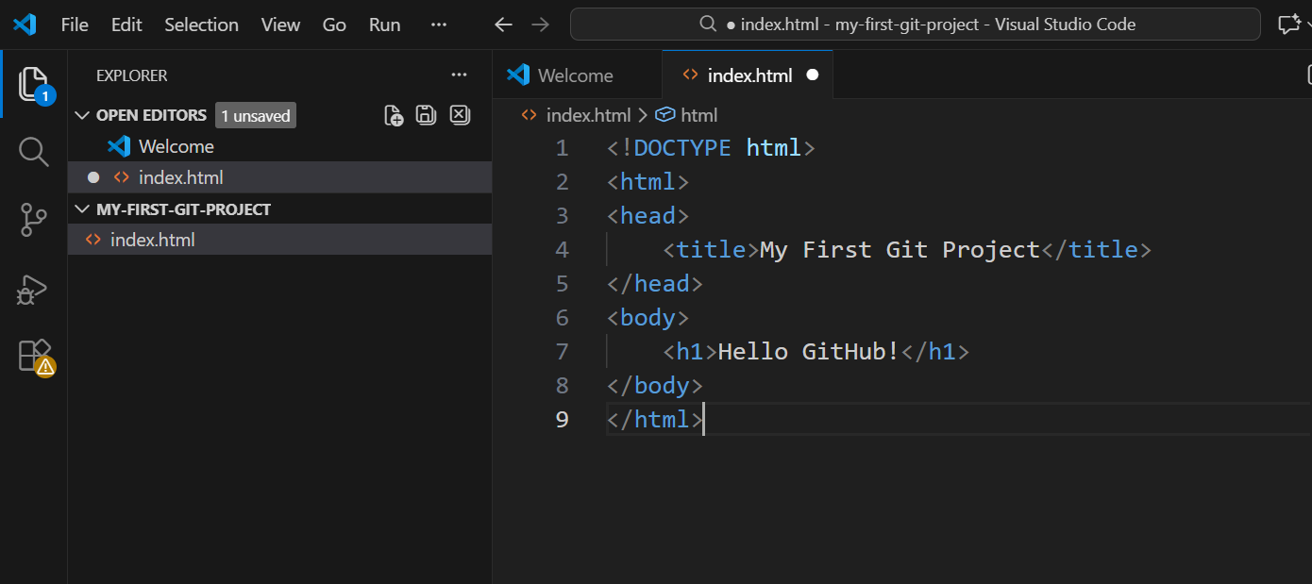
Environment Verification
Check Git Version
Navigation in Git Bash and Check Current Directory
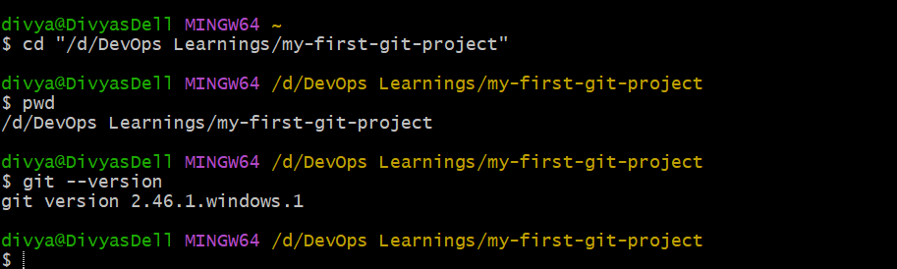
Initialize Git Repository and Check Repository Status
View Files in Directory
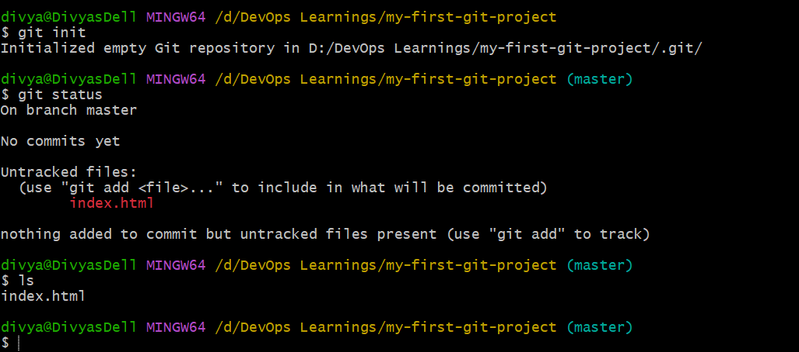
Now configure the username and email address of GitHub account in git bash
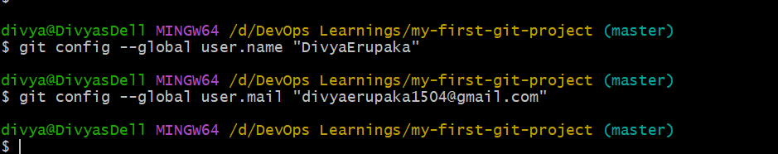
list the configuration
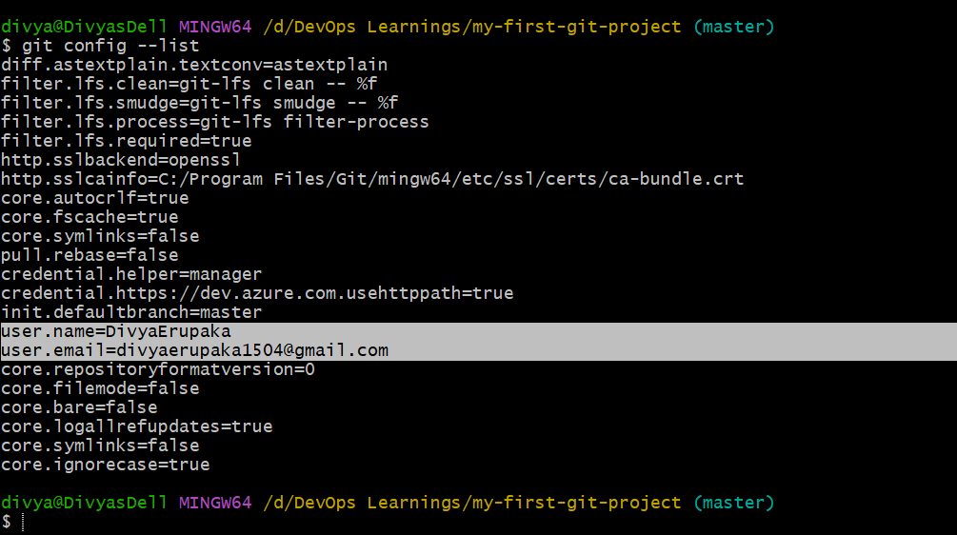
run git status here there is one untracked file and by running git add . the file as been added and then again check status now the file moved to tracked file.
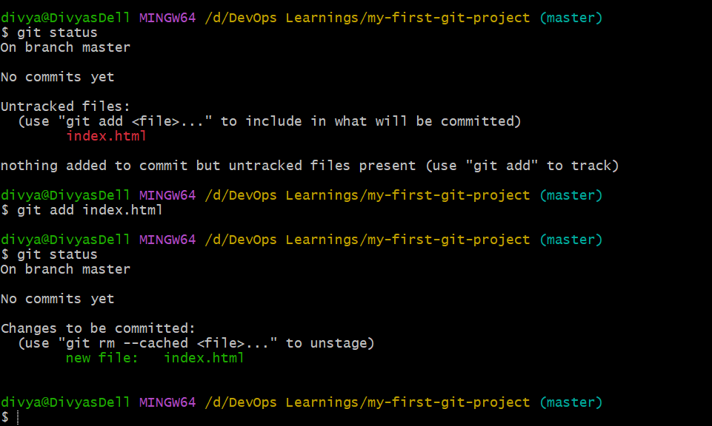
lets try adding few more file by using touch command and now status check and then add command and then again check status files gets moved to tracked files.
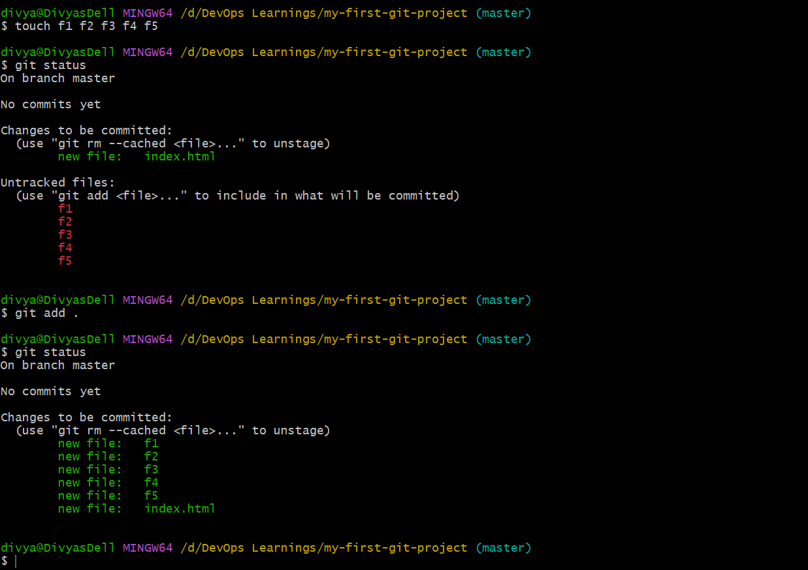
Now commit all the files
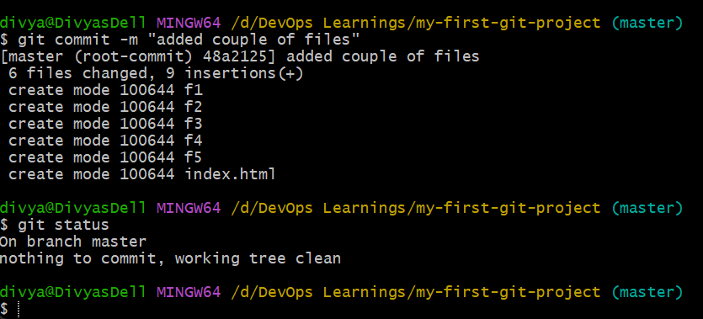
Check logs and you will find commid id of the committed
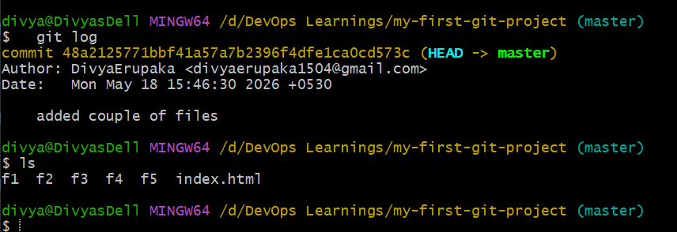
now again try adding f6 file do the same process
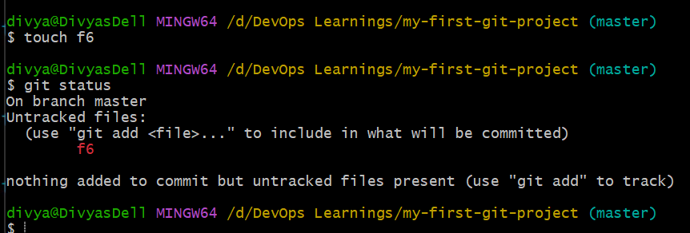
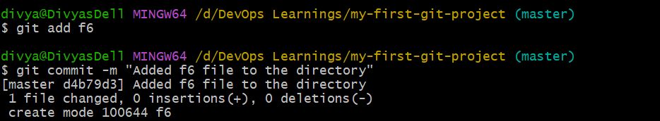
log of that commit will be shown
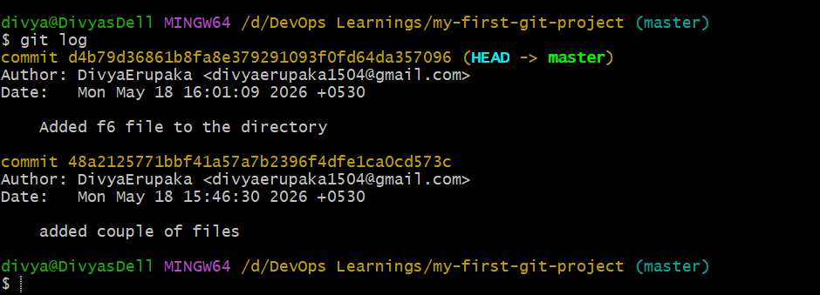
Create a repo in Github account
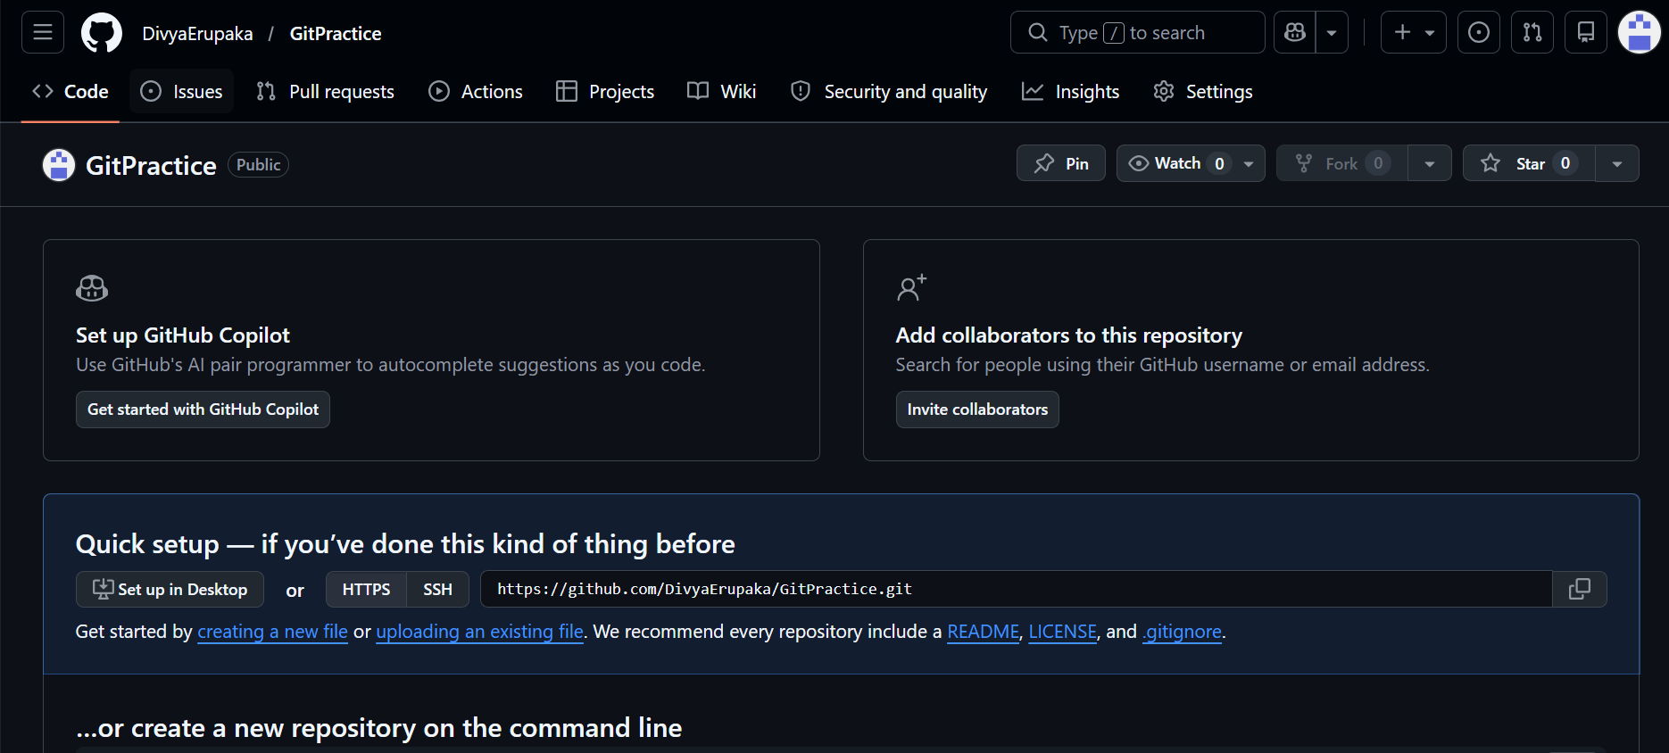
git remote add origin and the attach url of git repo to the command
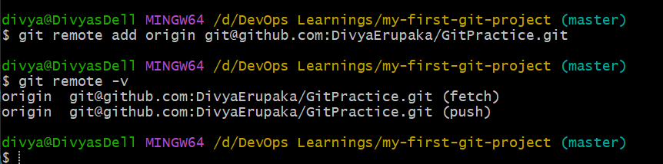
now run git push -u origin master but there was some issue that it is asking for public key
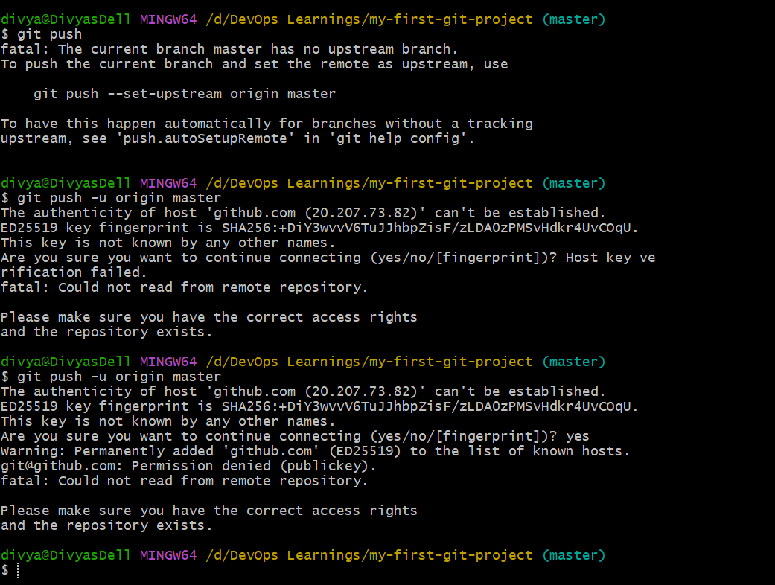
Generate the key using ssh-keygen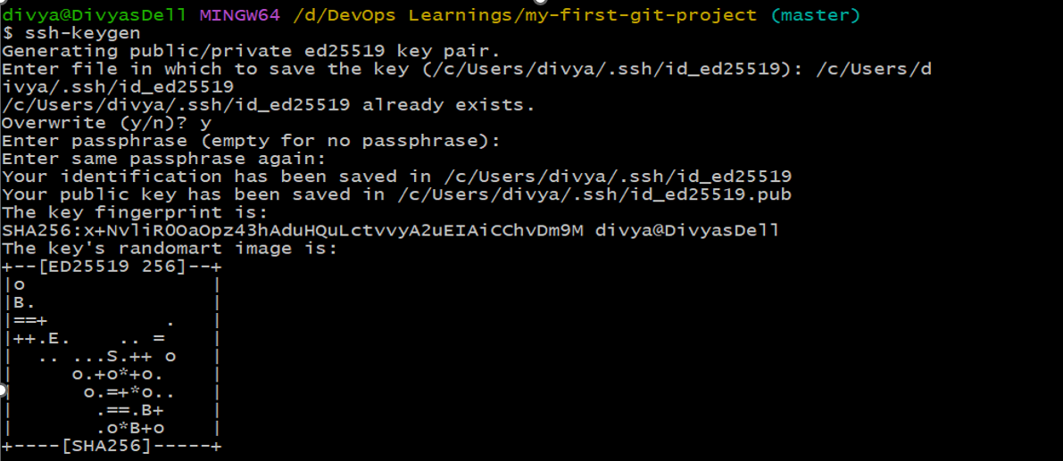
copy the key
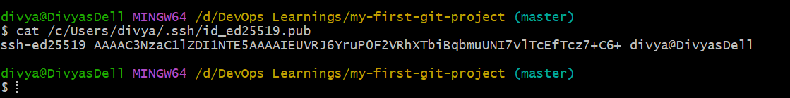
add it to the github ssh key location
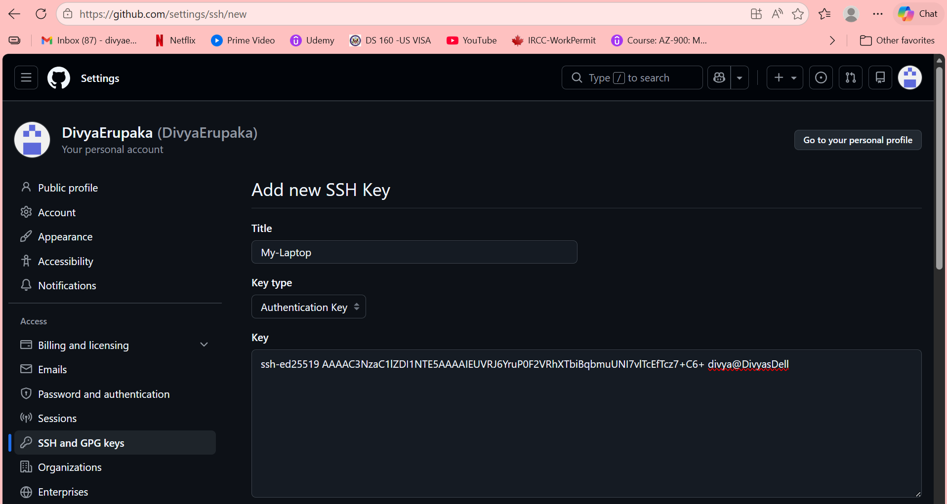
Successfully added the key to github.
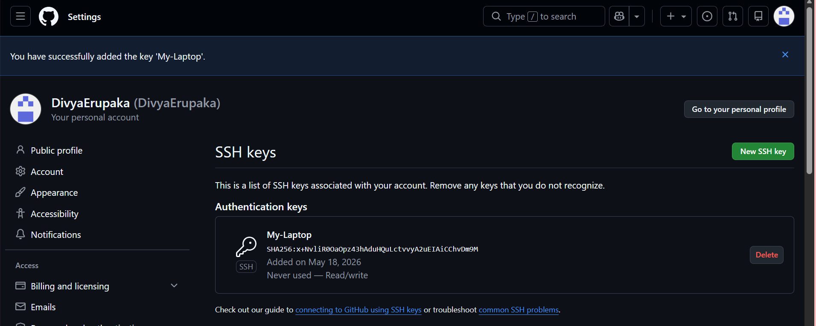
now try push command it will push all the files to the github successfully.
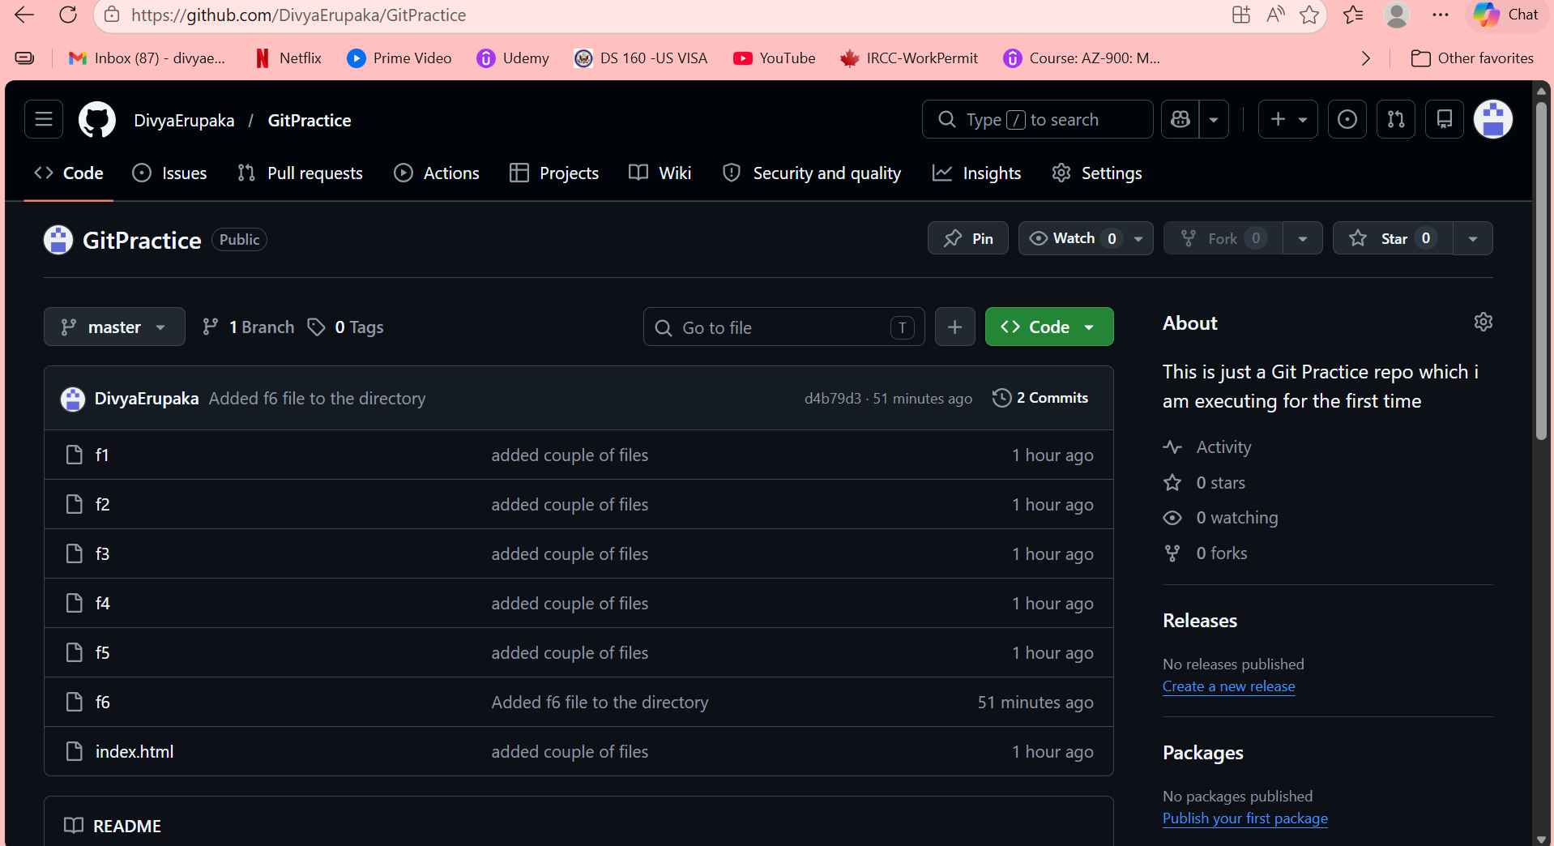
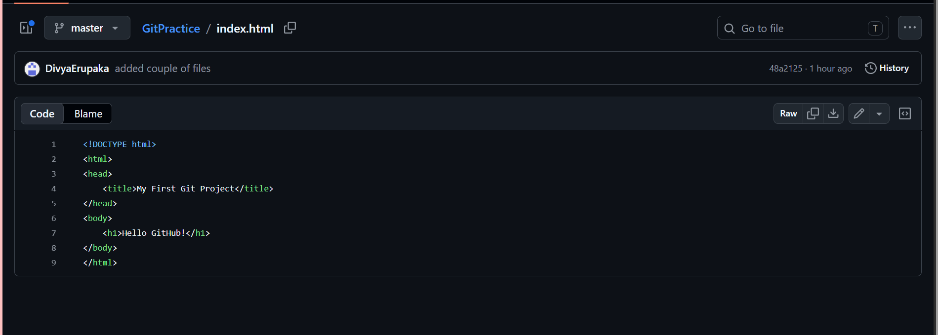
now try deleting a file and check the git status
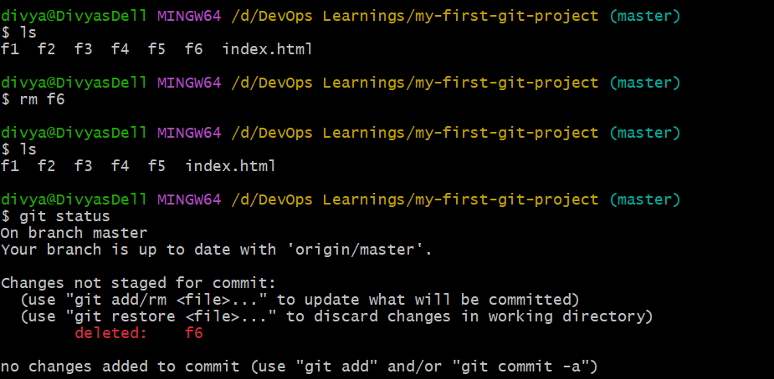
Run Git add . and check status it will me moved from untracked to tracked.
then commit and push and f6 file will also get deleted from the git repo
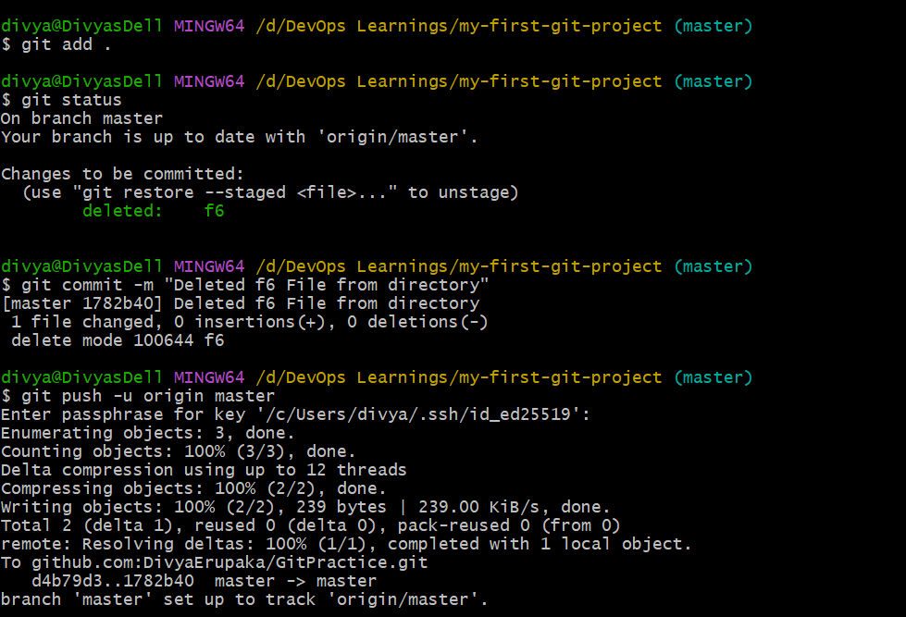
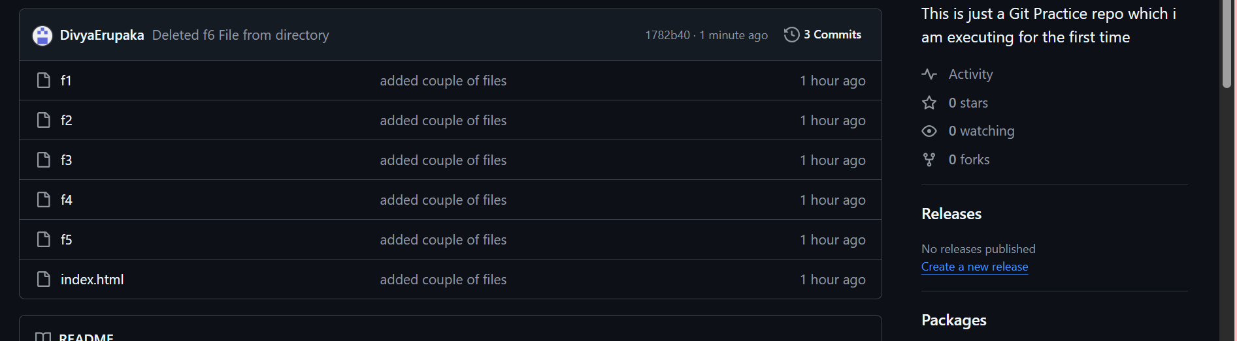
Here I have added and tested file 10 manually in github.
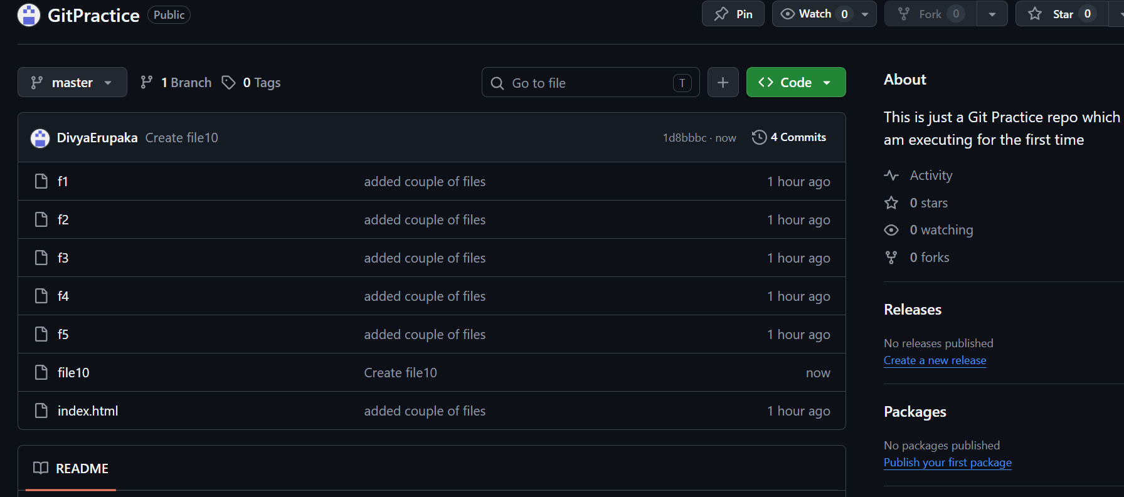
but it doesn’t shown in local machine
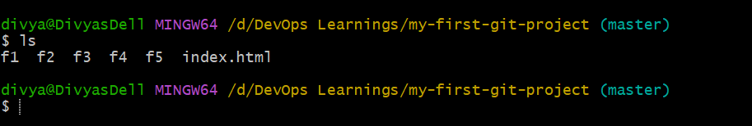
and try adding new file and add and commit
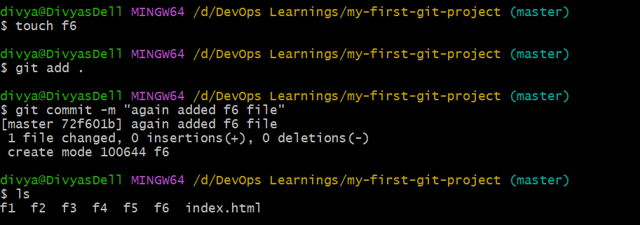
then push so it won’t be pushed as the manually created file was not pulled.
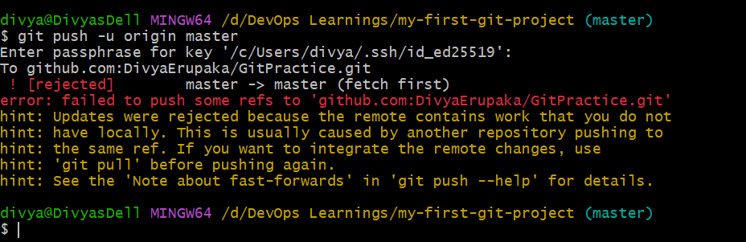
Now it is pulled
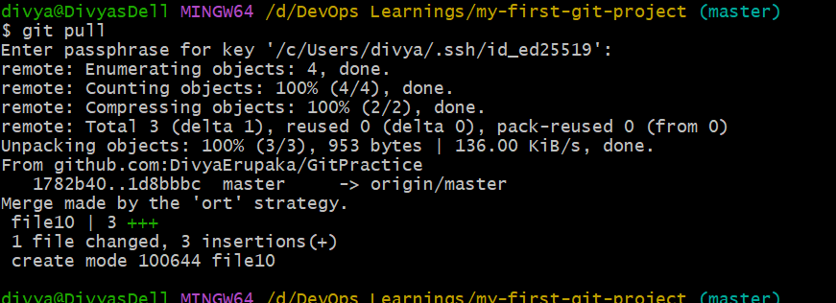
all the files are listed and pushed
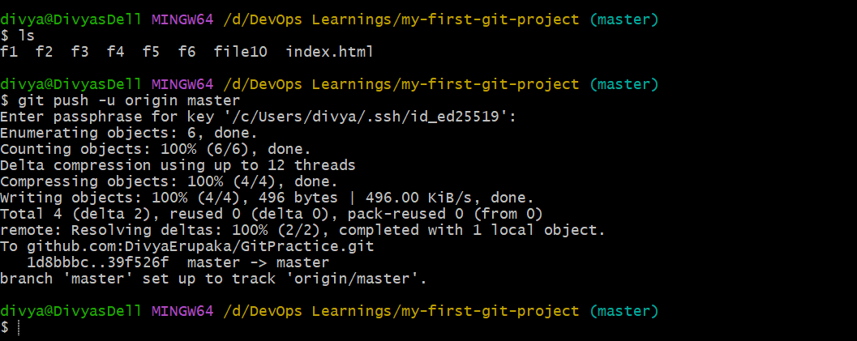
also displayed in github
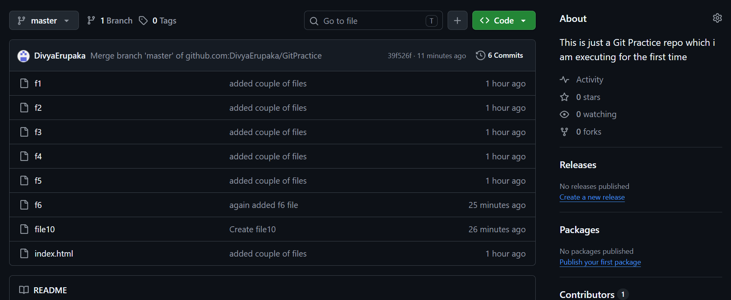
Cloned GitHub repository:
Moved into repository all the files from github repo got cloned in GitPractice/ new repo
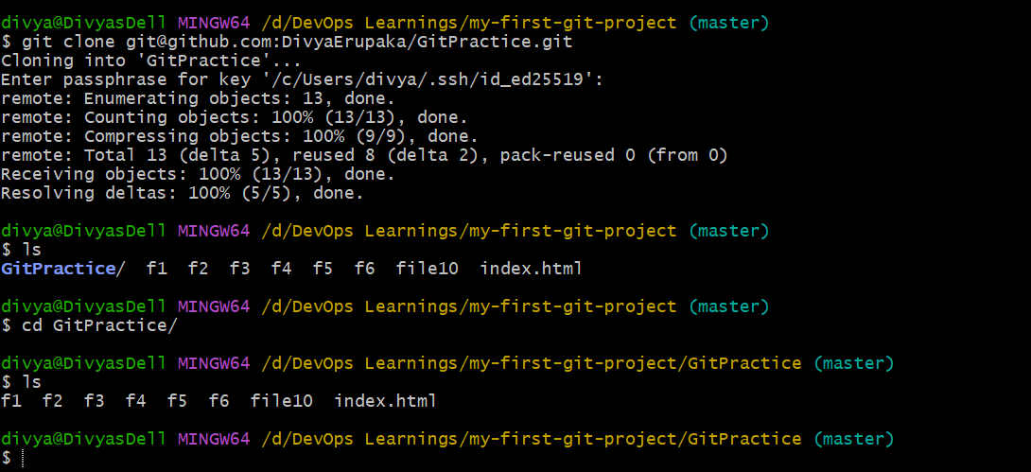
Deleted file F5
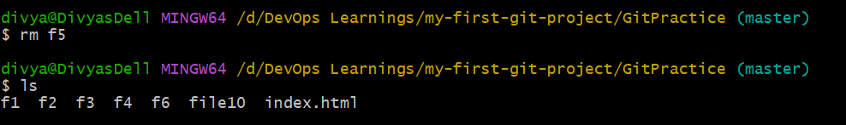
Stage and commit and then Push changes
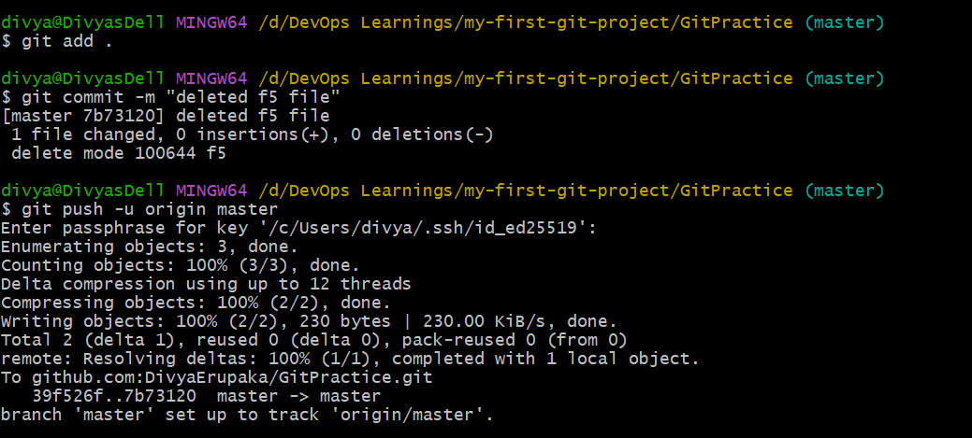
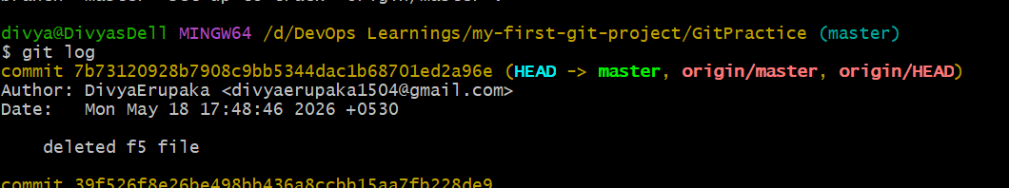
Reverted deleted file commit
This restored the deleted file without rewriting history.
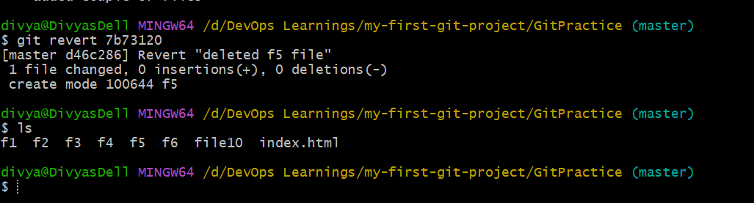
Created new file alphabet , added file,
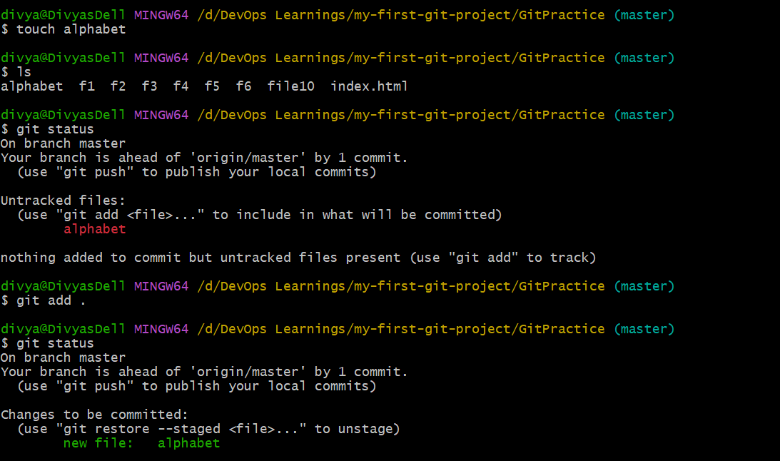
Reset staged changes
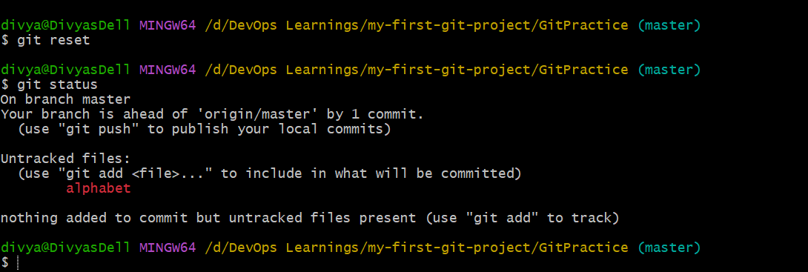
Important Git Commands Practiced
Command | Purpose
git init | Initialize repository
git status | Check repository status
git add . | Stage all files
git commit -m | Commit changes
git log | View commit history
git remote add origin | Add remote repository
git push -u origin master | Push code to GitHub
git pull | Pull latest changes
git clone | Clone repository
git revert | Revert a commit
git reset | Unstage files

